Practical - 2
Practical Title: Semantic HTML5 Pages with Accessibility-Ready Structure

Problem Definition: Develop static HTML5 skeletons for at least 10 StudentHub pages such as Home, About, Register, Login, Dashboard, Events, Profile, Contact, Admin, FAQ, and Feedback. Use semantic tags and accessibility-friendly structure.

Theory

Are semantic tags such as header, nav, main, section, article, aside, and

footer used properly?
Answer: Yes. Semantic HTML5 tags are used properly to define the different parts of the Student Hub pages. The <header> is used for introductory content, <nav> is used for navigation links, <main> contains the main content of the page, <section> groups related content, <article> contains independent content, <aside> contains related or supplementary content, and <footer> contains footer information. These semantic elements help browsers, developers, search engines, and screen readers understand the structure of the webpage.

Reference Link:
https://www.w3schools.com/html/html5_semantic_elements.asp

Are form labels, headings, image alt text, and navigation links

accessible?
Answer: Yes. The StudentHub pages use proper <label> elements for form controls, which helps screen-reader users understand the purpose of each input field. Headings are arranged in a logical order using <h1>, <h2>, <h3>, etc. Images include appropriate alt text to provide alternative information when an image cannot be viewed. Navigation links also use clear and descriptive text so users can understand where the links will take them. These practices improve the accessibility and usability of the website.

Reference Link:
https://www.w3schools.com/html/html_accessibility.asp

3. Is the page structure consistent across all pages?
Answer: Yes. The Student Hub Portal follows a consistent structure across the website. The same basic layout is maintained using a common header, navigation area, main content section, and footer. The navigation menu is kept consistent so users can easily move between pages such as Courses, Assignment, Attendance, Result, About Us, and Settings. A search bar and Login/Sign Up options are also provided for easy access. This consistent structure makes the website easy to understand, navigate, and use.

Reference Link:
https://www.w3schools.com/howto/howto_website.asp

Implementation/ Output/Result
- <!DOCTYPE html>
- <html>
- <head>
- <title>Student Hub</title>
- <body>

- <h1 align="center">Student Hub Portal</h1>

- <input type="text" placeholder="Search">

- <a href="Login.html">Login</a>
- <a href="Sign up.html">Sign Up</a>

- <hr>

- <h3>Menu</h3>

- <ul>
- <li><a href="Courses.html">Courses</a></li>
- <li><a href="Assignment.html">Assignment</a></li>
- <li><a href="Attendance.html">Attendance</a></li>
- <li><a href="Result.html">Result</a></li>
- <li><a href="About us.html">About Us</a></li>
- <li><a href="Settings.html">Settings</a></li>
- </ul>

- <h2>Welcome to Student Hub Portal</h2>

- <p>
- Students can access Courses, Assignments,
- Attendance, Results and more.
- </p>

- </body>
- </html>

Evidence of Work (Screenshots)

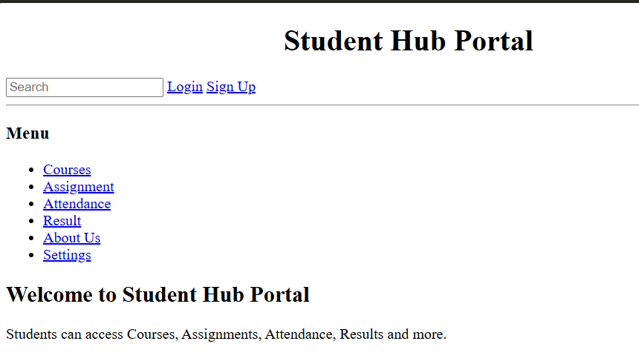Description: This figure shows the StudentHub Home Page created using HTML5 semantic elements. The page contains a header with the StudentHub title, a navigation menu, main content sections, and a footer. The navigation links provide access to other pages of the StudentHub portal
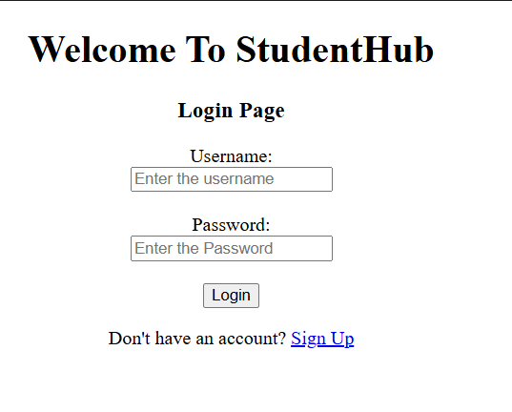
Description: This figure shows the StudentHub Registration/Login Page containing accessible form elements. Each input field is associated with a proper label, making the form easier to understand and use with assistive technologies. The page follows the same header, navigation, and footer structure used throughout the StudentHub website.

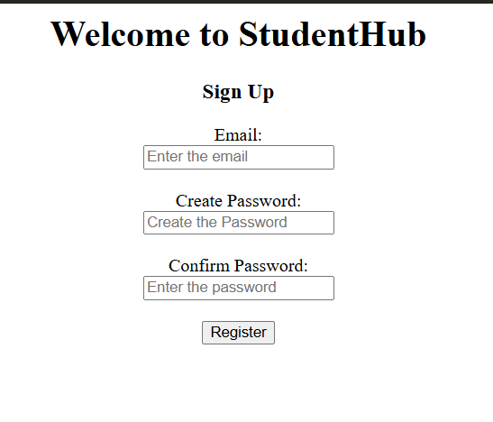
Description: This figure shows the StudentHub Sign Up page. It contains fields for entering the user's email, creating a password, and confirming the password. A Register button is provided to submit the registration form. The page has a clear and simple structure for new users to create an account.
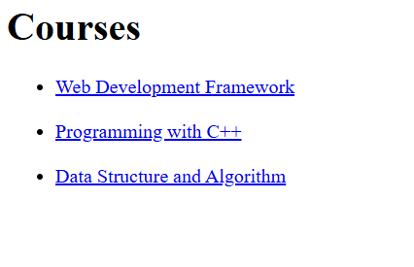
Description: This figure shows the Courses page of the StudentHub portal. It displays a list of available courses, including Web Development Framework, Programming with C++, and Data Structure and Algorithm. Each course is presented as a clickable link that allows the user to view its details.
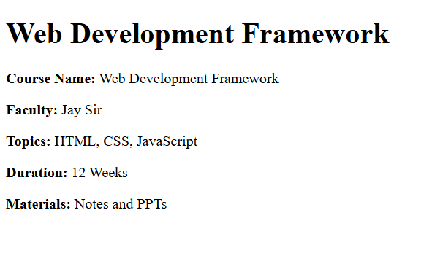
Description: This figure shows the Web Development Framework course details page. It provides information such as the course name, faculty, topics, duration, and study materials. The topics covered are HTML, CSS, and JavaScript, with a duration of 12 weeks.
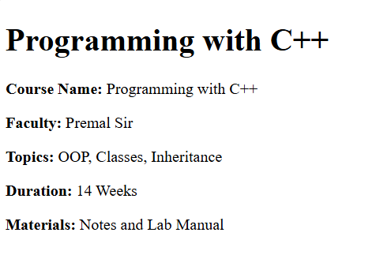
Description: This figure shows the Programming with C++ course details page. It displays the course name, faculty, topics, duration, and available materials. The main topics include OOP, Classes, and Inheritance, and the course duration is 14 weeks.

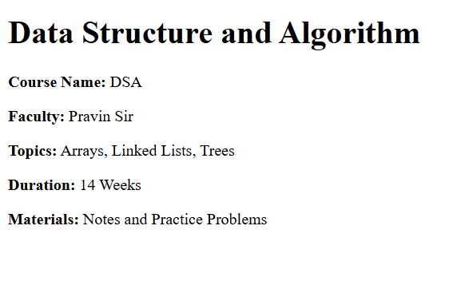
Description: This figure shows the Data Structure and Algorithm (DSA) course details page. It provides information about the course name, faculty, topics, duration, and study materials. The topics include Arrays, Linked Lists, and Trees, with a duration of 14 weeks.

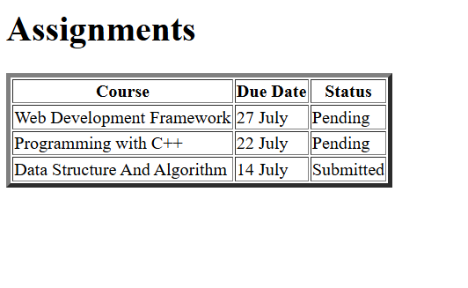
Description: This figure shows the Assignments page of the StudentHub portal. It contains a table displaying the course name, assignment due date, and submission status. The assignments are listed for Web Development Framework, Programming with C++, and Data Structure and Algorithm, with their respective statuses shown as Pending or Submitted.
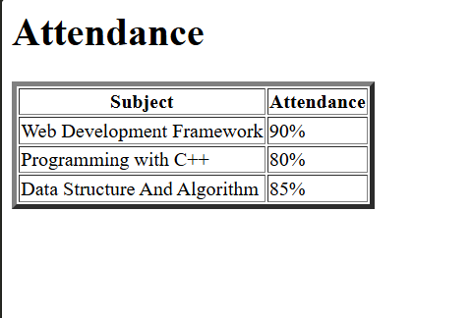
Description: This figure shows the Attendance page. It presents the attendance percentage for different subjects in a table. The attendance is shown as 90% for Web Development Framework, 80% for Programming with C++, and 85% for Data Structure and Algorithm.
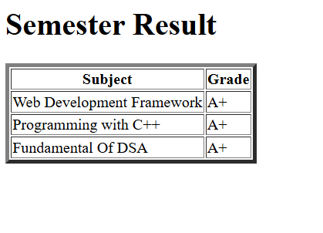
Description: This figure shows the Semester Result page of the StudentHub portal. It displays the subjects and corresponding grades in a table. The listed subjects—Web Development Framework, Programming with C++, and Fundamental of DSA—all have an A+ grade.
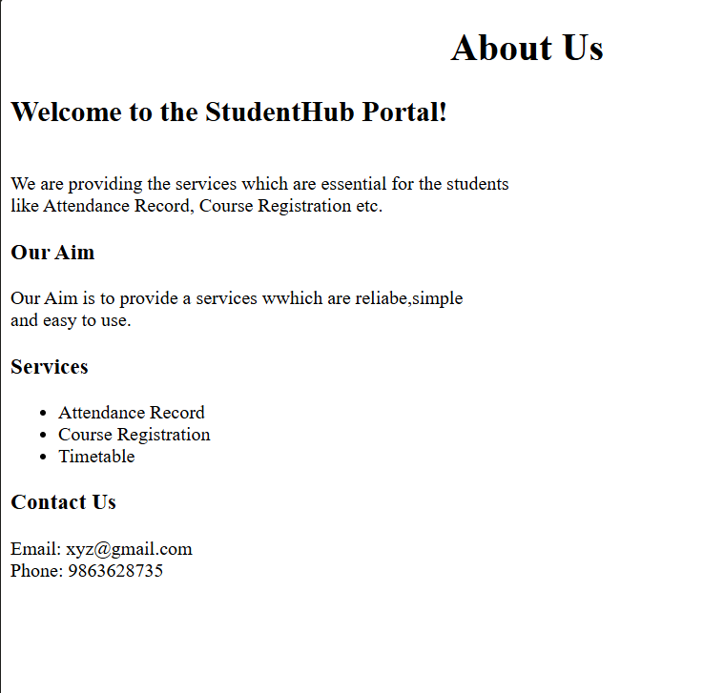
Description: This figure shows the About Us page of the StudentHub portal. It introduces the purpose of the portal and describes the services provided to students. The page includes sections for Our Aim, Services, and Contact Us. The services include Attendance Record, Course Registration, and Timetable, along with email and phone contact information.
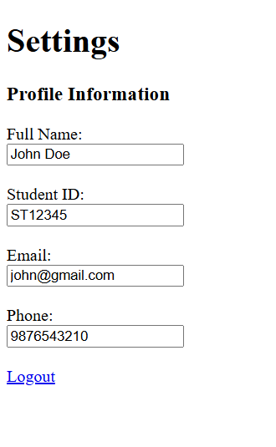
Description: This figure shows the Settings page of the StudentHub portal. It contains a Profile Information section with fields for the user's full name, student ID, email, and phone number. A Logout link is also provided so that the user can securely exit their account.

GitHub Repository Link:

https://github.com/devanshirshah24-pixel/WDF-Practicals/tree/main/Practical2

Challenges Faced:
During the implementation of the StudentHub pages, the following challenges were faced:
- Understanding semantic tags: Initially, it was difficult to decide when to use <section>, <article>, <aside>, and <div>. This was solved by understanding the purpose of each semantic element.
- Maintaining consistent navigation: The same navigation structure had to be maintained across all pages. This was solved by using the same navigation links and order on each page.
- Making forms accessible: Associating labels correctly with input fields was initially challenging. This was solved by using the for attribute in <label> and matching it with the input's id.
- Page linking: Connecting all HTML pages using <a href=""> links required careful checking of file names and paths.
- Maintaining consistent page structure: The same header, navigation, main content area, and footer were maintained across all pages.

Learning Outcomes:
After completing this practical, I learned:
- How to create HTML5 semantic page structures.
- How to use <header>, <nav>, <main>, <section>, <article>, <aside>, and <footer>.
- How to create and connect multiple HTML pages using navigation links.
- How to create accessibility-friendly forms using proper labels.
- How to use meaningful alt text for images.
- How to organize headings in a logical hierarchy.
- How to maintain a consistent website structure across multiple pages.
- How semantic HTML improves the understanding and accessibility of web pages.
- How to inspect and test the accessibility of HTML pages using browser accessibility tools.

Faculty Remarks: (Keep this blank for faculty)

